**Summary**

Missing station in application “Bus Plus”(version 2.2), station name “Trg Republike”, number 532 [Android]

**Description**

On application “Bus Plus” there is one station missing. The station is called “Trg Republike” and its ID is 532. When we enter number 532 in “Pretraga stanica” the station is not showing. We know that station exists as it’s shown in the video and photos below

**Steps to reproduce**  
1. Open Bus plus application  
2. Tap on „PRETRAGA STANICA PO BROJU”  
3. Tap on „Unesite broj tražene stanice“  
4. Observe the offered stations

**Expected Result**  
1. When we entered 532 in „Unesite broj tražene stanice“ we should be able to see the station with number 532 called „Trg Republike”

**Actual Result**   
1. We don’t see the station with ID number 532 called „Trg Republike”

**Repro rate**

10/10 100%

**Severity**High  
**Priority**  
High

**Screenshots:**

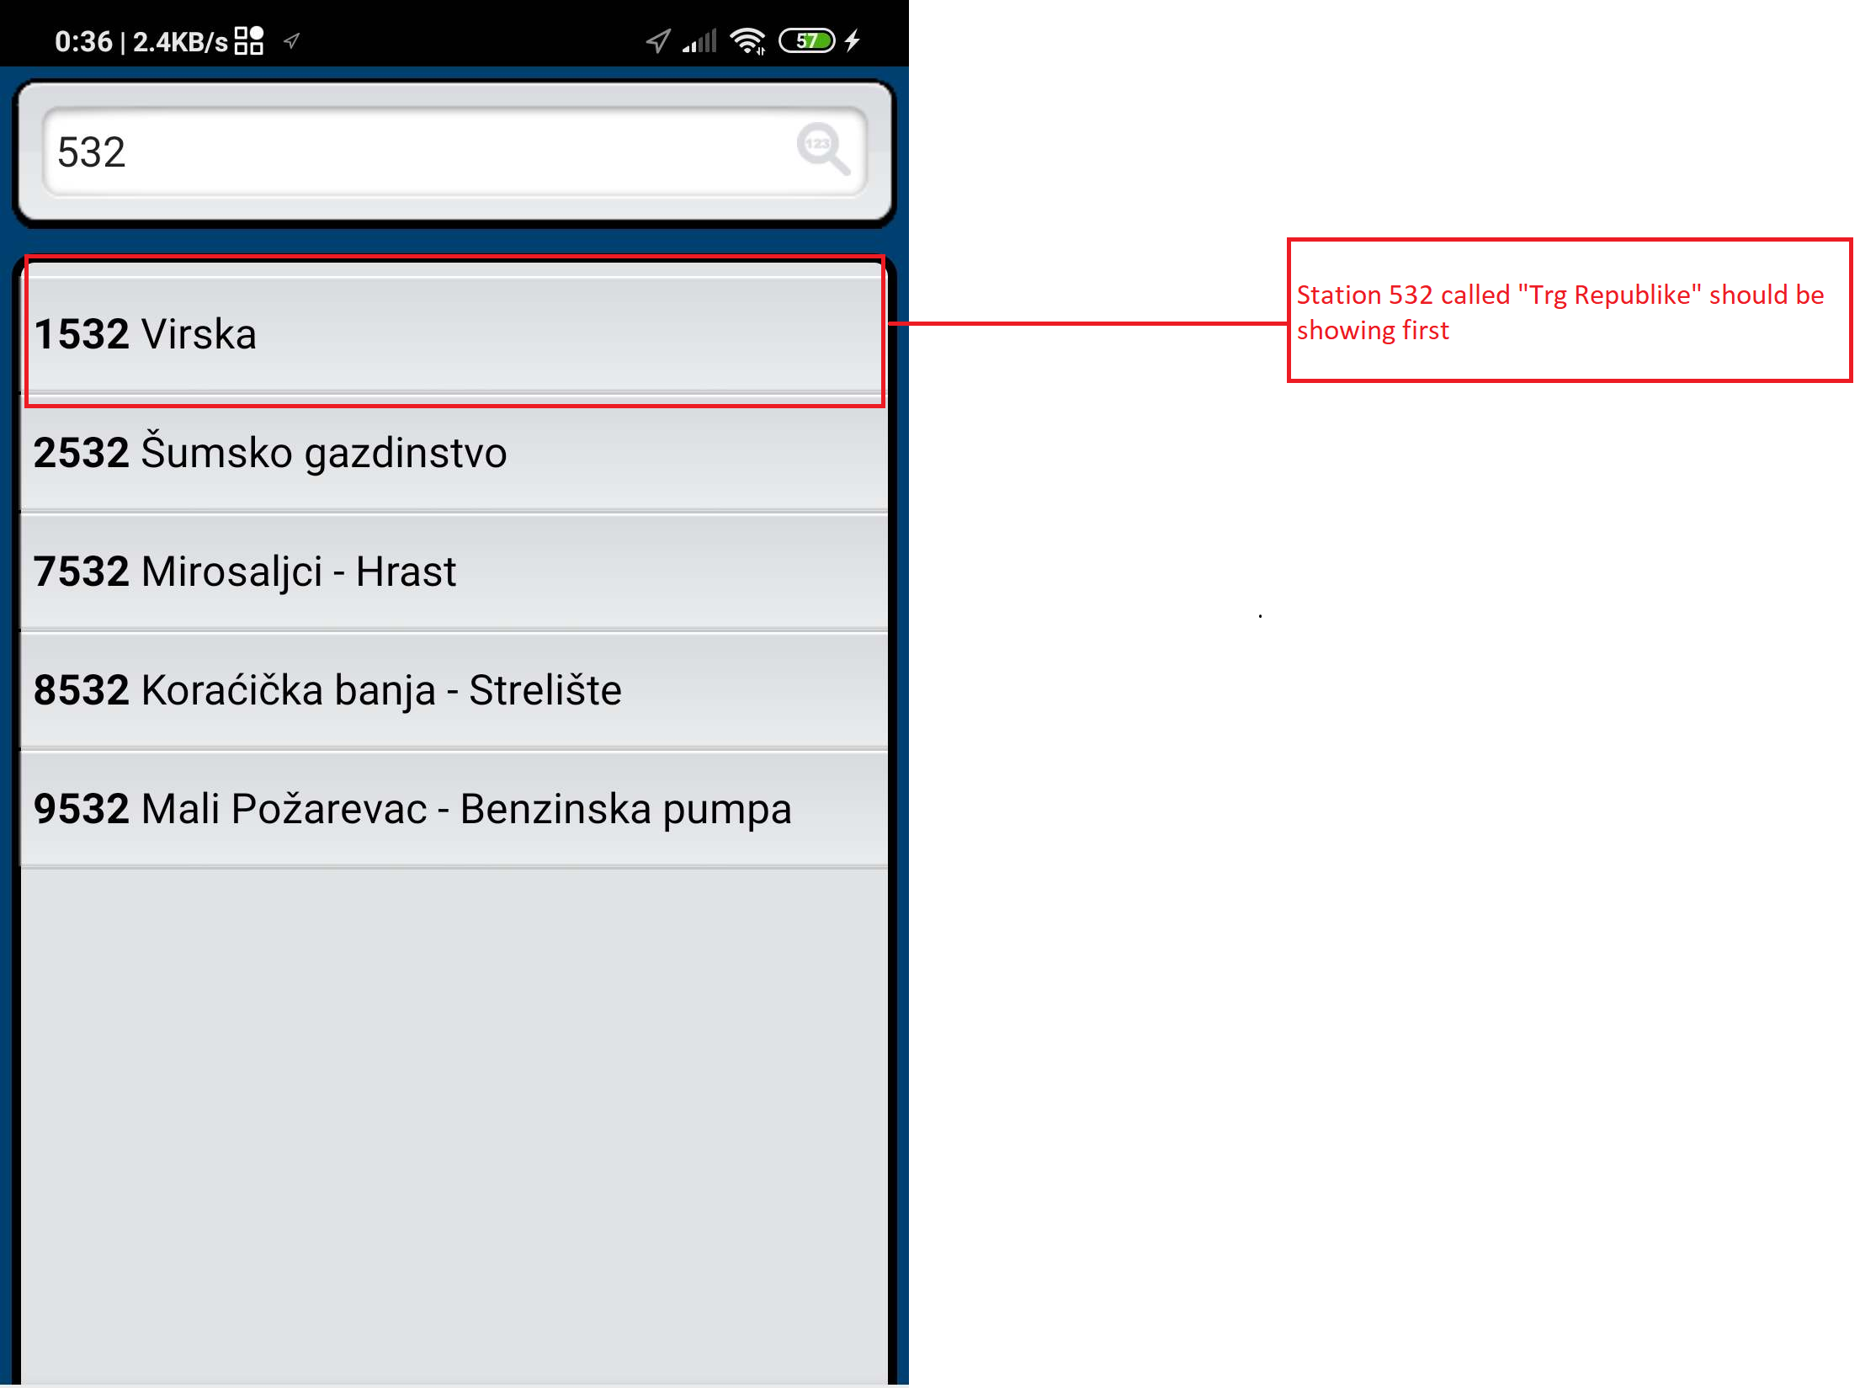

**Photo as evidence that the station exists**